Lab W1D3 Solutions

Q1.Solution

A.

Algorithm removeDups(L,n)

Input - List of integers with duplicate values

output – List of integers without duplicates

s🡨 new HashSet();

s.addAll(List l) // add all list elements to hashset

l.clear() // clear list elements

l.addAll(s) // back all elements of hashset to list

return list;

B.

Time complexity of Algorithm 4 is O(n)

C.

Time complexity of Algorithm 4 is the same as Algorithm 3 which is given to us on the lecture.

Q2.Solution

Algorithm beautiful(A, n)

Sum🡨0

For i🡨0 to n-1 do

Sum🡨 sum+ a[i]

Return sum

Beautiful Algorithm is an Algorithm with time complexity of Best- Case and Worst-Case tmie analysis have the same values which is O(n).

Q3.Solution

The order of time complexity is 2^n and 2^n+1 is O(2^n) and 2^2n is o(4^n), and 2^2^n is O(2^2^n) in increasing order .

2^n=2^n+1< 4^n< 2^2^n.

Q4.Solution

O(1) -> insertion and Deletion methods in Hash table, List.

O(n) -> radix sort, search on doubly linked list

O(log n) -> binary search

O(n log n) -> Quick sort, merge sort, time sort, heap sort

O(n^2) -> Bubble sort, merge sort, selection sort;

O(n^3) -> matrix multiplication , addition

O(2^n) -> Fibonacci number, generating all subsets from a set with n elements

Q5. Solution.

1. We can’t apply Master formula for Fibonacci number since b=1;

T(n) of recursive Fibonacci algorithm is O(2^n)

Tight upper bound is T(n)=O(1.6180)^n

B.

T(1) = d;

T(n) = T(n/2) + c;

A=1;

B=2;

K=0;

Compare a with b^k

1=2^0= => 1=1

Which means  (log n)

Q6. Master theorem

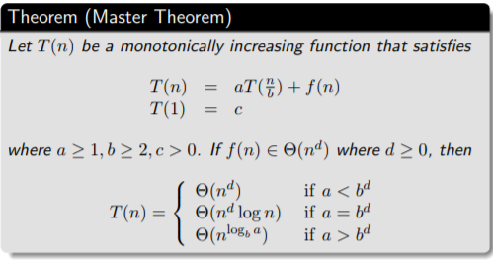

Emaples

Example 1,

Let T(n) = T n 2 + 1 2 n 2 + n. What are the parameters?

a = 1 b = 2 d = 2

Therefore which condition?

Since 1 < 2^2 ,

case 1 applies. Thus we conclude that

T(n) ∈ Θ(n^d ) = Θ(n^2)

Eaxmple 2.

Let T(n) = 2T n 4 + √ n + 42.

What are the parameters?

a = 2 ,b = 4, d = 1/2

Therefore which condition?

Since 2 = 4^(1/2) ,

case 2 applies.

Thus we conclude that

T(n) ∈ Θ(n^d log n) = Θ(√ n log n)

Eaxmple 3.

Let T(n) = 3T n 2 + 3 4 n + 1.

What are the parameters?

a = 3, b = 2 ,d = 1

Therefore which condition?

Since 3 > 2^1 ,

case 3 applies. Thus we conclude that

T(n) ∈ Θ(n^(logb a) ) = Θ(n log2 3 )

Note that log2 3 ≈ 1.5849 . . ..

Can we say that T(n) ∈ Θ(n^(1.5849))